**Understand the Showcase with IMAX’s EBITDA Margin**

When the Showcase with IMAX’s EBITDA Margin (34%) is compared to AMC’s EBITDA Margin (17.7%) it may appear to be inflated. This, however, is not the case. In actuality, its AMC’s EBITDA Margin that’s deflated when compared to global theater standards.

Industry Investment Analysis Group, Redwood Capital, in a report labelled, ‘**CINEMA OPERATOR INDUSTRY Sector Review May 2014**’, compiled the following:

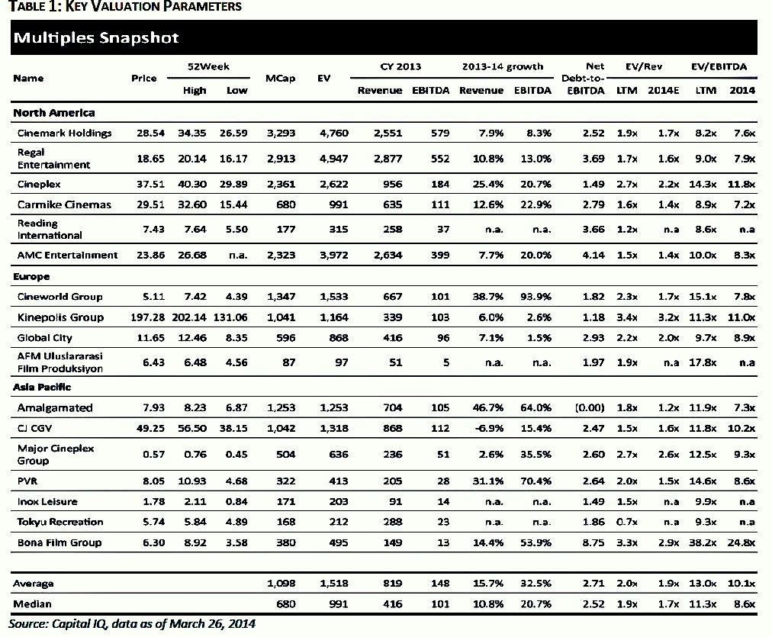

This noted report pegged the Global EDITDA Margin at 32.5%. Hence when evaluating the Showcase with IMAX’s EBITDA Margin (34%), the same falls in line with global standards.

However, if US investors still want an appraisal of Showcase’s EBITDA Margin with a US Cinema Chain, a more appropriate comparison is in order.

For financial assessment purposes, it is more relevant to liken a chain with similar conditions as that of the anticipated investment in the Bahamas. For reasons that will be laid out in the analysis, Marcus Theaters (the 5th Largest US Theater Chain) is a better comparison:

**Analysis:**

*1. Demographics*

**AMC** is a nationwide company, yet it obtains more than 40% of its revenue from the top 5 cinema markets. There they compete with other national cinema brands for market dominance.

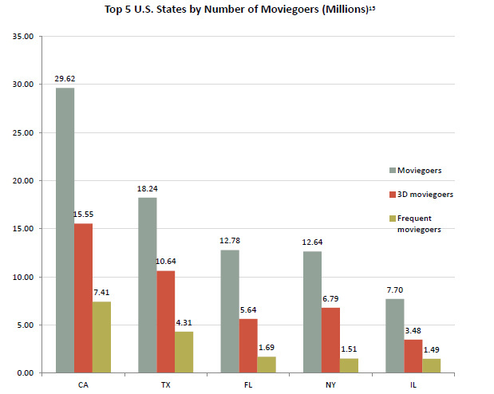

(Courtesy of the Motion Picture Association of America)

**Marcus Theaters’** demographic approach is centered on smaller communities in only seven Midwestern states. In 83% of the markets it inhabits, Marcus Theaters is in the top two players in those territories.

Why?

Marcus Theater applies the ‘Bigger Fish in Smaller Pond’ Approach. Though they have cinemas in bigger cities, Marcus tackles communities between 90,000 to 1,500,000 people where competitors lack the resources to respond to their acclaimed product mix.

**Showcase with IMAX’s** demographics are more aligned with Marcus Theaters.

Why?

In the Nassau, with a population of 300,000 there will only be two operators (Showcase and Galleria Cinemas). Showcase will be introducing its exclusive product mix of 3D, IMAX, 4DX and VIP services to a market where **only** 2D movies are offered by is sole competitor.

*2. Entertainment Options and Their Direct Effect of Ticket Sales and Concessions*

**AMC** has seen a large increase in concession sales. For the first quarter 2015, food and beverage revenues were a record $200.5 million, compared to $181.8 million for the quarter ended March 31, 2014. Food and beverage revenues per patron increased 10.6% to $4.48, an all-time high.

AMC Ticket revenue has been another story. Though concessions revenue has increased steadily over the last five years, tickets sales have decreased. Ticket revenue has been bolster by higher ticket prices, namely IMAX and 3D premiums. Removal of these two revenue catalysis show an even sharper decline in ticket sales and revenue.

**Marcus Theaters** from 2004 to 2014increased its per-person concession and ticket revenue in every single year.

Why?

AMC is in larger cities where they are competing for the entertainment dollar with diverse entertainment choices. Marcus Theaters, however, is bucking national trends of declining admissions by competing in markets where they have the main attractions for miles around. These communities make cinemas the destination of choice because it is the only choice. There are fewer concerts, sporting events even few high end restaurants. This allowed Marcus Theater to come into communities and offer full service dining options in their theater, thereby strengthening their concession sales.

**Showcase with IMAX** enters under similar conditions in this small market. With no professional sports teams or cultural event centers, entertainment options for families are limited to a single bowling alley. There are tremendous possibilities for growth in the family dining sector. With VIP theaters offering dine in amenities as well as a full service restaurant, the same will thrive. When consideration is taken for Showcase’s location, 2 minutes away from a new $3.5 Billion resort Bah Mar, the potential begins to be revealed. Tourist will face the same issues as locals; nothing do besides the beach.

*3. Real Estate Positioning Strategy*

Marcus Theaters owns 85% of its properties vs **AMC** that owns only 5% of its properties (operate on a leased-theater model). This is tremendous because Marcus Theaters can minimize its rental expenses (fixed costs) and lower its operating leverage, hence they see a lower decrease in net profit when compared to AMC.

Moreover, since Marcus owns most of its theaters, it can do major upgrades to its facilities and continue to be competitive over longer periods of time. Conversely, AMC owners must worry about lease conditions and get landlord approvals for extensive renovations. This slows innovation and further decreases competitiveness.

**Showcase with IMAX** similarly to Marcus Theaters owns its property, hence allowing the same strategic flexibilities outlined above.

*Conclusion*

With all of the aforementioned strengths of the Marcus Theater brand there is no coincidence that they have maintained an **EBITDA Margin between 26-28% for the last five years**. This is more in line with the global average in the industry and very close to Showcase’s 34% margin. It should however be noted that the Showcase EBITDA Margin is a blend rate for the entire facility.